Lab 12

Aaron Eberly

NOTE: I messed up with the index for the list and tuple for the first few screenshots. However, it is later fixed (I used index 1 instead of index 0).

Try/except

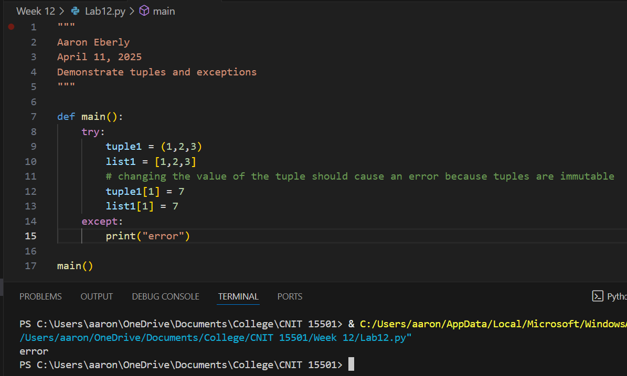

Try/exception_EXCEPTION

Ask Copilot (2 images)

Copilot help

What exception:

NOTE: Ignore the thing about TTRPGs. That’s a memory Copilot has from previous conversations, and is unrelated.

Exception handling order matters (2 images):

Why does exception order matter? (3 images):

My elxplanation:

In other words, the first except statement that is valid will be carried out, and the rest will be ignored. In this way, except statements are similar to elif statements. Because of this, more specific except statement should be placed before general ones.

What are exceptions (3 images)?

Trying my own exceptions:

